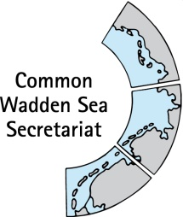
MEETING DOCUMENT
Task Group Management (TG-M 22-3)
21 June 2022
Online

Agenda Item: 6.2 Framework Sustainable Fisheries – assessment of status
Subject: Topical meeting Sustainable Fisheries
Document No.: TG-M 22-3/6.2
Date: 13 June 2022
Submitted by: CWSS

See document on Assessment of the Framework Sustainable Fisheries (TG-M22-/6.1).
This document contains a proposal for a topical meeting sustainable fisheries.
Proposal: The group is invited to note the information and agree on topical meeting fisheries

Workshop with fisheries experts: Assessment of Framework sustainable fisheries principles- completion of status and collection of advice for management

Proposed outcome:
- Full status assessment of the Framework Sustainable Fisheries principles, based on the input of TG-M members. If necessary identification of gaps.
- Draft recommendations/management advice based on the status assessment and draft conclusions of full assessment.
- Proposal on next steps.

Draft Agenda:

- Opening of the Meeting and adoption of the Agenda
The meeting will be opened by the chairperson at TIME on DATE 2022. Participants will be invited to adopt the draft agenda of the meeting.

- Status Framework Sustainable Fisheries
TG-M2022-Fisheries-2-Framework-Sustainable-Fisheries-status-recommendations.docx
Discuss status assessment, secure balanced input by countries and common understanding of entries to tables and text. Identify gaps. Proposal: Agree on structure procedure to fill possible gaps

- Recommendations/advice for management
Based on the status assessment, draft first recommendations/advice for management and conclusions eight years after Tonder.
Proposal: Agree on wording (recommendations/advice for management,..), agree on first input and agree on procedure to finalise document

- Any other business
Discuss any other business

- Closing of meeting
The meeting will be closed by the chairperson at TIME on DATE 2022.

