Draft

SUMMARY RECORD

NETWORK GROUP
Sustainable Tourism
NG-ST 24

Hippolytushoef, The Netherlands
30 October 2019

(comments by Monique, Eric, Sjon + Mira)

1. Opening of the Meeting and Adoption of the Agenda
Document: NG-STS 24/1-draft agenda

This meeting chairman, Sjon de Haan, opened the meeting and welcomed the participants. An introductory round for first time participant Mira Hohmann (NLPV Lower Saxony) was conducted. A list of participants is in Annex 1. The proposed draft agenda of the meeting was adopted without amendments. The agenda is in Annex 2.

2. Summary Record NG-ST 23
Document: NG-ST-23-draft-minutes-2019-06-14 Final Draft Minutes (send by email 14 June.2019)
Comments on the draft version were received from the national parks in Lower Saxony and Schleswig-Holstein and have been integrated in the final version.
The meeting adopted the amended summary record of the NG-ST 23 meeting without any further amendments.

3. Announcements

Germany, Schleswig-Holstein
LKN-SH (information sent by mail):
- Regional „Fachtagung Nature and Tourism“ in Schwabstedt (https://www.nationalpark-wattenmeer.de/sh/service/publikationen/fachtagung-2019/5501 ) with presentations about Birdwatching, off-season offers, examples of actions against plastic waste
- National Park Topic of the year 2020: Underwater Worlds
- INTERREG VA project NAKUWA: 22 German and Danish Birdwatching guides have successfully passed examen and present their new offers (https://www.nationalpark-wattenmeer.de/sh/vogelbeobachtung)
- Cooperation with Interreg project TOUR BO (sustainable Tourism across the german-danish border https://www.interreg5a.eu/blog/2-millionen-euro-foerderung-fuer-nachhaltigen-tourismus/) and the Cultural World Heritage Haithabu and Danevirke to discuss synergies and enhance networking

WWF
Ms Szczesinski informed the meeting about:
- NAKUWA: WSWH Explorer – App with walking/hiking routes which in the future may also be expanded to map routes in Lower Saxony + the Netherlands

- PROWAD LINK, WP 5: Study on carrying capacity and limits of acceptable change for tourism in the North Sea Region and in particular in the Wadden Sea World Heritage destination in preparation. Workshop planned for 10 of December in Hamburg with the aim to identify the most relevant questions related to carrying capacity and limits of acceptable change for tourism in the North Sea Region and in particular in the Wadden Sea World Heritage destination and to identify relevant study sites in the WSWH region.

Germany, Lower Saxony
Ms. Hohmann informed the meeting about:
- Study on regional effect of a national park (Job Studie) planned for 2020 with first results in 2021.
- The annual Welterbe Forum will take place on the 19 November in Stadland – review and presentation with focus on 10 years World Heritage.
- Dark Sky initiative in Lower Saxony: Spiekeroog ambitions on becoming a dark sky community. An excursion to share experiences is in preparation with the Nationalpark Lauwersmeer (Dark Sky park). In Lower Saxony the dark sky activities will be further explored in Wattenagenda 2.0 (Work Package light pollution)with the idea to form a trilateral network. (Amendment: Meanwhile a trilateral working group has been established)
- 11th Migratory Bird Days (12 – 20 October) successful finalized (21.000 participants). Date 2020: 10 – 18 October, partner country Portugal, bird of the year: Avocet)
- Municipalities bordering the national park are invited to talks after which they will decide to participate in the biosphere reserve in mid-2020.

Denmark (information passed to Ms. Domnick in oral form):
- the National Park launched the world heritage partnership programme
- trend report on tourism and nature nearly finalized in PROWAD LINK, WP 6.

The Netherlands
Ms Pruyt gave an overview about the planned activities in the Wadden agenda 2.0:
- Work package on the accessibility of accommodation Week of accessibility 2020 in Leeuwarden
- Topic/theme. Cultural heritage in combination with natural heritage to create more products and raise visibility
- Meeting / New Group (through Waddenfonds) that looks at value chain from food production to the consumer; PRW Event on regional food.
- Mooiste Natuurgebiet workshop on sustainable tourism (Monique + Sjon participating).

4. Overview on planned or ongoing regional WH activities
No written announcements were submitted to the meeting.

Discussion about anniversary events 2019 lesson learnt and how to cooperate in the future?
Proposal to further elaborate by Roger Davids (ppt as extra attachment) with the aim to get more engagement in the regions/locally and to establish in a trilateral context.

  - Insight in the Dutch marketing campaign (by Roger Davids)

Overview about the aims and objectives of “Visit Wadden”, target groups and instruments. The ppt is attached for more information.
Question raised in the meeting: how to connect to the existing communication of WSWH to have a consistency? What are the differences / overlaps / trilateral connections?
The project Visit Wadden has a funding for 6 years – what happens afterwards?

  - Dutch programme “Strengthening Wadden Sea World Heritage” (by Sjon de Haan)

Programme seen as instrument to implement the Action plan in the Netherlands.

The objectives are:
• improving the quality, experience, unlocking and accessibility of tourist-recreational offers and optimizing the experience of the core qualities; vastness, peace, darkness, silence, valuable landscapes and cultural heritage
• strengthening the tourism structure through cooperation and networking.

Different focus areas:

Education: e.g. Info Centers
Quality trainings
Digitalisation
a meeting is planned to address how identity and meet challenges.

Terps: How to make the history visible through tangible products where visitors
will stop and spend money

Cycling routes - make cycling along the dike possible

Overview on planned or ongoing trilateral WH activities
5.1. PROWAD LINK project – Presentation of the Brand Activation Concept
Presentation was postponed due to low number of participants at this meeting.

5.2. Preparation ITB 2020 – Introduction ITB Steering Group
At the TG-STS 23 meeting it was decided to establish a steering group to oversee and help to keep the progress of the planning of ITB 2020 on track. The steering group is responsible for ensuring links between CWSS/TWSC and the regional partner needs. Ms. Domnick reported on the status:

Appointed members of the ITB Steering Group, selected from the PROWAD LINK partners and TWSC:
Jens Laurits Hansen – DK
Catharina Greve – D / LKN-SH
Anke Hofmeister (Mira Homann) – D/NLPV
Sjon de Haan – NL
Carolin Pupelis – Wadden Agenda
Jane Madvig Søndergaard - NAKUWA
Anja Domnick– TWSC/CWSS

The objectives for next year:
In general: Stressing the ONE Wadden Sea <-> 3 countries perspective together with a strong commitment to UNESCO and sustainable tourism in protected areas/WH sites.

- within the trilateral WH communication:
- to strengthen people’s appreciation and respect of the World Heritage
- to keep the public broadly informed about our World Heritage Site and of the activities taking place in Denmark, Germany and The Netherlands.

- PROWAD LINK project:
- Boosting visibility & credibility of local SMEs at ITB;
- Networking opportunity & platform for knowledge sharing for B2B/B2C-activities to create brand positioning within the industry

ITB Timeline (subject to changes):
- Stand registration by 1 September 2019 (done)
- Registration of Co-Exhibitors by 2 December 2019
- Update exhibitor entry by 15 January 2020
- Register events for official approval by 31 January 2020
Ms. Domnick informed the meeting that on the occasion of the 10th anniversary of the Wadden Sea World Heritage, the multi-stakeholder, strategic “Trilateral Partnership in support of the Wadden Sea World Heritage” was founded by signing a common Memorandum of Understanding (MoU). The MoU was also signed by the touristic partners of the region. In the context of this meeting it was decided to put the envisioned Partnership Hub on next meeting agenda to get more in-depths information and to discuss what it implies for the group.

6. Preparation Sustainable Tourism Strategy and Action Plan 2018 – 2022

The final draft of the action plan was adopted at NG-ST 23 but so far names of persons who would be responsible for the activity towards the NG-ST (regional focal points, or project activity leader) are still pending.
Due to the small group, there was no in-depth discussion, but the meeting stressed the importance of addressing how the action plan is managed (locally) and who is doing what. Therefore, CWSS was tasked to prepare a paper as a basis for discussion in due time before the next meeting.

As attachment to these minutes the terms of reference for the NG-St as well as the current member list will be circulated with the request to be checked in the regions and to update the member list as seen as necessary.

7. Next Meetings
The proposed meeting dates for the next NG-ST meeting were scheduled in combination with PROWAD LINK project meetings which have changed. Therefore, a doodle request will be sent out in due time to fix the next meeting date. Planned for first quarter of the year.

8. Any Other Business
The meeting agreed to submit relevant information in written form to the group when members are not able to participate at the meeting.

9. Closing
The chairman thanked all participants for their cooperation and closed the meeting at 12:30 h.

ANNEX 1 - List of Participants NG-ST-24

Mr Sjon de Haan (Chairman)  Coordinator Werelderfogoed Waddenzee  Huis voor de Wadden  Ruiterskwartier 121 A  NL 8911 BS Leeuwarden  Phone +31 619 712 309  s.dehaan@waddenzee.nl | Ms Monique Pruyt  Provincie Fryslân  Tweebaksmarkt 52, Postbus 20120  8900 HM Leeuwarden  Tel 31 (0) 58 2925887  m.pruyt@fryslan.frl
Mr Michel Aaldering  VVV Terschelling/Nordzicht  Willem Barentszkade 19a  8881 BC West Terschelling  +31(0)6 55305421  m.aaldering@vvvterschelling.nl | Mr Roger Davids  Merk Fryslân  Zuidergrachtswal 2  8933 AD Leeuwarden  Phone +31 6 53285162  roger@merkfryslan.nl
Mr Mira Hohmann  Nationalparkverwaltung  Niedersächisches Wattenmeer  Virchowstr. 1  D - 26382 Wilhelmshaven  phone: +49 (0) 4421 911-282  Mira.hohmann@nlpv-wattenmeer.niedersachsen.de | Ms Anja Szczesinski  WWF - Germany  Hafenstraße 3  D - 25813 Husum  Phone + 49 (0)4841 66 85 45  Fax: + 49 (0)4841 66 85 39  anja.szczesinski@wwf.de
Ms Stephanie Rohenkohl  Amt für regionale Landesentwicklung  Theodor-Tantzen-Platz 8  D - 26122 Oldenburg  Phone: +49 (0)441 799 2395  stephanie.rohenkohl@arl-we.niedersachsen.de | Mr. Eric Neef  Koninklijke Nederlandse Toeristenbond ANWB  Zwedenlaan 22, 9403 DE Assen  Mobile +31 (0)6 51358296  eneef@anwb.nl
Mr Peter Ros  Ministry of Economic Affairs / RVO  Phone: +316 52401597  Peter.Ros@rvo.nl | Ms Anja Domnick (project officer PROWAD LINK)  Common Wadden Sea Secretariat  Virchowstr. 1  D - 26382 Wilhelmshaven  phone: +49 (0)4421 9108-24  fax: +49 (0)4421 9108-30  domnick@waddensea-secretariat.org

ANNEX 2
Annotated
Proposed Draft AGENDA
NETWORK GROUP SUSTAINABLE TOURISM
NG-ST 24

Hippolytushoef, The Netherlands

30 October 2019

1. Opening of the Meeting and Adoption of the Agenda
The meeting will commence at 09:00. Adoption of the draft agenda of the meeting.

2. Summary Record NG-ST 23
The meeting will be invited to approve the final draft Summary Record of NG-ST 23.

3. Announcements
Exchange of information on relevant issues not covered by the other agenda items.

4. Overview on planned or ongoing regional WH activities
The members are invited to report ongoing or planned bilateral/regional projects implementing the strategy and action plan on the regional level (The Netherlands, Lower Saxony, Hamburg, and Schleswig-Holstein, Denmark) in order to coordinate and link the activities trilaterally by the NG-ST, and to specify what kind of support is expected from NG-ST members.
NG-ST members should provide information about ongoing local activities by mail before the meeting to CWSS.

  - Insight in the Dutch marketing campaign (by Roger Davids)
  - Dutch programme “Strengthening Wadden Sea World Heritage” (by Sjon de Haan)

5. Overview on planned or ongoing trilateral WH activities
5.1. PROWAD LINK project – Presentation of the Brand Activation Concept
5.2. Preparation ITB 2020 – Introduction ITB Steering Group

6. Preparation Sustainable Tourism Strategy and Action Plan 2018 – 2022
The draft Action Plan was prepared by TG-STS 22 which was distributed for comments. NG-ST was proposed to agree on a draft plan for submission to WSB 29 (18 - 19 June 2019) which was postponed. It now has to be addressed, how the action plan is managed (locally) and who is doing what.

7. Next Meetings
Proposed Meeting date: 4-5 February 2020, Denmark (with Prowad LINK Forum),

8. Any Other Business
The meeting will be invited to discuss any other business.

9. Closing
The meeting will be closed at 12:30 at the latest.

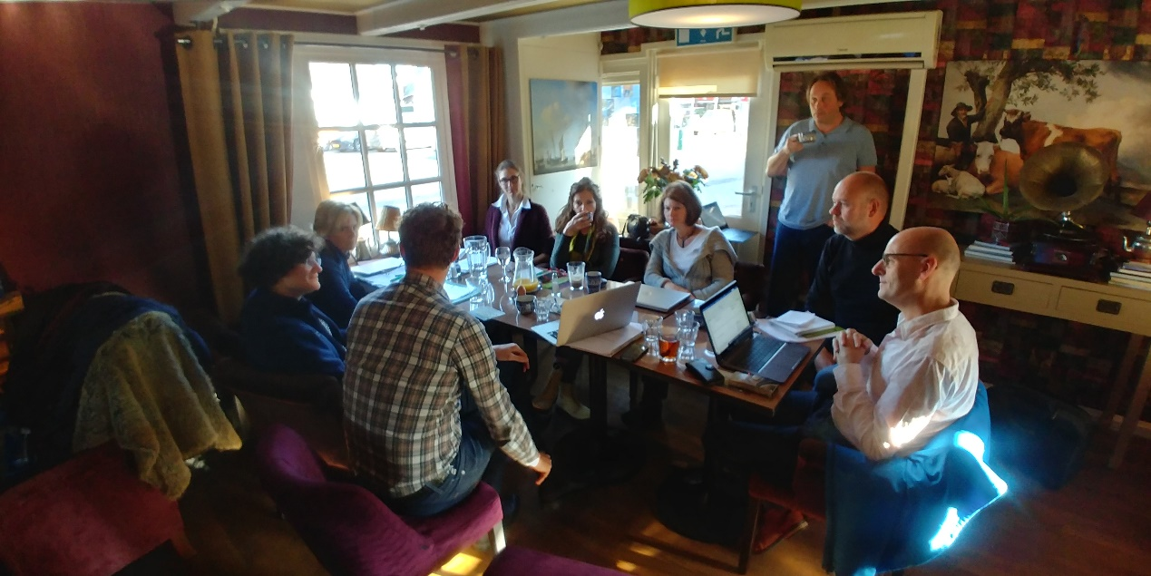
Foto Eric Neef

