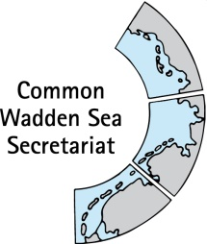
MEETING DOCUMENT
Expert group Climate Change Adaptation (EG-C 12)
9 February 2022
Online meeting

Agenda Item: 2. Summary record
Subject: Draft summary record
Document No.: EG-C 12/2
Date: 7 February 2022
Submitted by: CWSS

This document contains the draft summary record of the EG-C 11 meeting.

Proposal: The group is invited to adopt the draft summary record
Version Log (will be deleted, this is for my personal overview)
Issue Date | Version | Author | Change
2021-12-08 | v0.1 | CWSS | First draft of the document, excluding 3. Announcements, action items and annex 4,5
2021-12-09 | v0.1 | chair | Minor changes, updated list of action items, cleaning of Annex 3, approval
2021-12-16 | v0.2 | CWSS | Inclusions of changes, annex 4, 5
 |  | WSF
 |  | SHK
 |  | WWF | Minor amendment
2022-01-20- | v0.3 | CWSS | Consolidation to v 0.3

DRAFT SUMMARY RECORD v0.3
Meeting of the
Expert Group Climate Change Adaptation (EG-C 11)
8 December 2021
Online meeting

- Opening of the Meeting and adoption of the Agenda
The meeting was opened by the chairperson Robert Zijlstra 09:00 on 8 December 2021 by MS Teams.
A list of participants is at Annex 1.
The EG-C adopted the draft agenda of the meeting (Annex 2).

- Adoption of the draft summary record
All action items of the previous meeting were completed or are part of this agenda, except:
1 take up WSB discussion for SMART work plan – postponed to first meeting 2022
2 OUV assessment -deadline extended to 1 February 2022
4 Review EG-C achievements of 2021 and to plan activities for the next presidency, which include review of the CCAS and possible new lean and mean priorities – postponed to first meeting 2022
Omit 9/ 7
The chair informed on the soon expected workshop report completion of the Climate Vulnerability Index (CVI) developers, for the CVI 2 workshop on Community Vulnerability. Following the completion of the report, a two-pager on outcomes of the workshop in response to the workshop report will be developed by EG-C the Task Group World Heritage (TG-WH) and CWSS.
Additions to the summary record:
Jannes Fröhlich informed on his parental leave from March to June 2022. In case of meetings Annkatrin Weber will join if necessary.
The EG-C noted the information and adopted the draft summary record of EG-C10

- Announcements

Denmark
Started discussion for topics and chairmanship for Danish presidency of the Trilateral Wadden Sea Cooperation (TWSC);
The project ARSINOE – CLIMATE-RESILIENT REGIONS THROUGH SYSTEMIC SOLUTIONS AND INNOVATIONS is on-going. In that project the four municipalities and Danish partners are looking at the Wadden Sea as project area for resilient regions.
Schleswig-Holstein,
In November, SH State Government adopted the 2021 update of the Spatial Development Plan Schleswig-Holstein. For the first time, it includes so called “Areas of Preference (priority areas) for coastal flood defense and protection (CFDP) and for climate change adaptation (CCA) along coasts”: (1) coastal stretches landward of state dikes (50 m) and regional dikes (25 m), (2) dike foreland, (3) coastal stretches 150 m landward of cliff edges as well as 150 m landward of the seaward edges of dunes and beach walls, and (4) coastal flood risk areas that are not sufficiently protected by state dikes or comparable flood defenses (in SH about 345 km2). In these areas, the issues of CFDP and CCA have priority over competing land use claims. The areas are to be kept free of new plans and measures that are in conflict with the interests of CFDP and CCA (i.e., building ban areas).
The five coastal States have jointly evaluated part I of the sixth IPCC report (the scientific basis) and concluded that the already agreed implementation of a precautionary allowance for a sea-level rise of one meter per century in the design of primary flood defense measures is still valid. It is recommended to further consider building reserves and/or land provision (forehandedness) while designing these measures.

Lower Saxony
- H2020 funded REST-COAST (Large scale restoration of coastal ecosystems through rivers to sea connectivity) started, including pilot sites in Lower Saxony. Evaluation of models and strategies are planned.

Netherlands
- Deposition and sale of dredged sand on land was stepwise reduced in the Netherlands, with the aim to reach zero input on 1 January 2022, to reduce negative impact on sand balance in the Wadden Sea;
- MANABAS: RWS is lead partner, for nature strengthening and coastal defense.
- www.icais.org: 22nd International Conference on Aquatic Invasive species will be held 18-22, 2022 in Oostende, Belgium;
- Draft report on large scale sand nourishment in Ameland inlet has been completed (in Dutch). Robert Zijlstra will share this with the group;
- The annual delta programme was published and includes a strong plea to better incorporate climate change adaptation in spatial planning, e.g., to discuss building houses in areas vulnerable to flooding.

WWF
- A proposal for the Interreg VIB project MANABAS Coast (MAinstreaming Nature Based Solutions through COASTal systems) is being prepared under the North Sea Region programme. Lead Rijskwaterstaat, NL. WWF is considering joining the project (as partner of LKN.SH) with the Halligen as pilot site;
- The new German coalition agreement contains a para on climate change adaptation (translated): on highest political agenda. translated the coalitions agreement on CCA:
We are developing a precautionary climate adaptation strategy, especially against the background of the flood disaster in 2021. With a climate adaptation law, we are creating a framework for implementing a national climate adaptation strategy with measurable goals, for example in the areas of heat prevention, health and allergy prevention and water infrastructure, and making timely adjustments to be able to. We will also take the first urgent measures very quickly with an immediate program. We are striving to anchor the joint funding of federal and state governments for climate protection and climate adaptation and want to provide them with sufficient financial resources. We are creating more space for innovation, digitization and private sector initiatives for climate adaptation. We see coastal and flood protection as a task for society as a whole and will financially strengthen the federal states and municipalities. We create national standards for the assessment of flood and heavy rain risks and the creation and publication of hazard and risk maps. We review the catalog of exceptions for the approval of construction projects in designated floodplains and adjust it, if necessary, with the aim of minimizing risks. We support private households with a KfW subsidy for private flood and heavy rain precautions. We support municipalities in investing in climate resilience, especially in a climate-proof water infrastructure that takes extreme precipitation and low water into account. With unsealing projects, we strengthen the infiltration of rainwater and reduce the risk of flooding.
WSF
TrilaWatt project has been granted. Aim is compilation of big datasets from the three Wadden Sea countries. The project will start January 2022, for three years. The CWSS with respect to TMAP has provided a letter of intent (LoI).

Waddenvereniging
The Dutch government has received a UNESCO letter, announcing concerns about new plans for gas extraction and plans for cable for wind farms though the Wadden Sea.

CWSS
- One additional Wadden Sea Board (WSB) meeting is planned for end of April 2022;
- H2020 funded REST-COAST (Large scale restoration of coastal ecosystems through rivers to sea connectivity) started. CWSS had provided a letter of support (as stakeholder) for this project. REST-COAST will demonstrate to what extent upscaled coastal restoration can provide a low-carbon adaptation, reducing risks and providing gains in biodiversity for vulnerable coastal ecosystems, such as wetlands or sea grass beds. By overcoming present technical, economic, governance and social barriers to restoration upscaling, REST-COAST will develop the large-scale river-coast connectivity and increase the nearshore accommodation space for the resilient delivery of coastal ecosystem services (ESS)
- MANABAS (see announcement WWF) preparation is on-going -CWSS considers being project partner as link to the TWSC and to the UNESCO marine site managers. A relation to EG-C may be with a workshop, e.g., on salt-marshes (exchange between Wadden Sea pilot sites), the dilemma of natural dynamics vs maintaining the system, to foster trilateral discussion on that topic. Also the trilateral Climate Change Adaptation strategy may be integrated;
- Community of Understanding (CoU) Sediment solutions: CWSS explores the relation of the CoU to trilateral work and connection of on-going activities e.g., of EG-C. Possibly, a CoU excursion could be aligned with EG-C excursion.
The group noted the information and thanked Frank Ahlhorn for offering a presentation about the TrilaWatt project.

- Trilateral Monitoring and Assessment Programme (TMAP) & Quality Status Report (QSR)
The chair informed on recent developments and called for suggestions for additional authors and/or reviewers. EG-C will be given the opportunity to review the draft thematic report.
EG-C noted that the thematic report on climate of the Quality Status Report (QSR) will be taken up early 2022 by Robert Zijlstra and Katja Philippart.

Jacobus Hofstede presented the State Master Plan for Coastal Flood Defense and Coastal Protection by including information on the Schleswig-Holstein situation climate monitoring.
The group discussed in particular the direction for a planned workshop(s) on climate monitoring for the Trilateral Monitoring and Assessment Programme (TMAP). First recommendations may be in the style of:
- Data are existing, but analysis is missing
- Parameters could include: Habitat area (salt marsh, tidal flat), geographical shift of species (including terrestrial), seasonal storm surges (in relation to breeding season of birds)
- Consistent calculations (how to calculate tidal flats)
- Meeting 9/1 Prepare a trilateral documentation on what kind climate related monitoring is being performed on regional level.
- Taking up climate change effects on a “smaller scale” in each QSR thematic report in future.
- Possibility for case study for analysis of existing data in cooperation with the TrilaWatt consortium
The group noted the information and agreed to support organizing (a) climate change TMAP workshop(s) in 2022, preferential are one workshop for geomorphology and coastal protection, and one for ecology. The group will recommend participants for the workshops before Christmas.

- Trilateral Governmental Conference and Ministerial Declaration
Document: EG-C11-5-TGC-MD

The group discussed EG-C contribution in a previous email consultation EG-C/Consultation/21-11-04 to the Policy Assessment Review (PAR), Ministerial Declaration (MD) and possible activities at the TGC based on online document.
The group agreed on addition to the PAR
The group agreed on recommendations for the MD (see Annex 5)
The group agreed that Claus von Hoerschelmann should start preparing a storybook for visualization (e.g., in a video or animation) of changes in the Wadden Sea and OUV due to climate change, possibly also including the trilateral Climate Change Adaptation Strategy. A combination with the idea presented by Frank Ahlhorn will be investigated.

- Any Other Business and next meeting
EG-C 12 Wednesday 9 February, 2022 (online)
EG-C 13 Tuesday 26 April, 2022 (online)
EG-C 14 summer, in person with excursion
The group noted the information.

- Closing
The Chairperson closed the meeting 12:30 on 8 December 2021 and thanked participants for a fruitful discussion.

ANNEX 1: List of participants
LIST OF PARTICIPANTS
Expert group Climate Change Adaptation
(EG-C 11)
8 December 2021
Online meeting

Chair
Mr Robert Zijlstra
Ministry of Infrastructure and Water Management
Noord Nederland
Leeuwarden
phone: +31 (0) 6 224 818 36
EMail: robert.zijlstra@rws.nl
Denmark
Mr Thomas Larsen  Ministry of Environment  Danish Coastal Authority  Højbovej 1, DK - 7620 Lemvig  phone: +45 99 63 63 63  EMail: tla@kyst.dk | Mr Klaus Bertram Fries  Varde Municipality  Bytoften 2 , DK - 6800 Varde  phone: +45 (0) 79 94 71 10  EMail: klbf@varde.dk
Germany (Hamburg, Lower Saxony, Schleswig-Holstein)
Mr Claus von Hoerschelmann  Schleswig-Holstein Agency for Coastal Defense, National Park and Marine Conservation  National Park Authority Schleswig-Holstein Nationalpark-Zentrum Multimar Wattforum Dithmarscher Straße 6a 25832 Tönning  Phone +49 (0)4861 9620-15  EMail: Claus.vonHoerschelmann@lkn.landsh.de | Mr Jacobus Hofstede  Ministry of Energy, Agriculture, the Environment, Nature and Digitalization Schleswig Holstein,  Mercatorstraße 3, D-24106 Kiel  Postfach 71 51, D-24171 Kiel  Phone: +49(0) 431 988 4984  Mobile: +49 1520 6537300  E-Mail: jacobus.hofstede@mlur.landsh.de
Mr Andreas Wurpts
NLWKN, Coastal Research Station Norderney/
An der Mühle 5
26548 Norderney
Phone: +49(0) 4932/916-121
Mob. +49 1711201875
EMail: Andreas.Wurpts@nlwkn-ny.niedersachsen.de
Netherlands
Mr Saa Kabuta
Ministry of Infrastructure and Water Management
Directorate of Water Affairs
Postbus 61
NL 8200 AB Lelystad
phone: +31 (0)6 29 38 23 19
E-Mail: saahenry.kabuta@rws.nl

Participants from advisors to WSB and external experts
Mr Jannes Fröhlich  WWF, Wadden Sea Office  Hafenstraße 3  D - 25813 Husum  phone: +49 (0)4841 66 85 58  mobile: +49 (0)151 18854818  jannes.froehlich@wwf.de |  | Ms Ester Kuppen  Waddenvereniging  Postbus 90  NL-8860 AB Harlingen  phone:+31 (0)6-10883266 kuppen@waddenvereniging.nl
Mr Frank Ahlhorn
Wadden Sea Forum (WSF)
Virchowstr. 1
D - -26382 Wilhelmshaven
phone +49 (0)4421 9108-18
mobile: +49 (0)151 12158443
E-Mail: ahlhorn@waddensea-forum.org
Secretary
Ms Julia A Busch
Common Wadden Sea Secretariat

ANNEX 2: Final agenda
FINAL AGENDA v1.0
Expert group Climate Change Adaptation
(EG-C 11)
8 December 2021
Online meeting

- Opening of the Meeting and adoption of the Agenda
The meeting will be opened by the Chairperson at 09:00 on 8 December 2021.
Proposal: Adopt the draft agenda of the meeting

- Adoption of the draft summary record
Document: EG-C11-2-SR-EG-C10
Proposal: Adopt the draft Summary Record of EG-C 10.

- Announcements
Announcements of participants.
Proposal: Note the information

- Trilateral Monitoring and Assessment Programme (TMAP) & Quality Status Report (QSR)
Presentation of State Master Plan for Coastal Flood Defense and Coastal Protection by Jacobus Hofstede. Information on Schleswig-Holstein situation climate monitoring will be fed into a panned TMAP climate workshop.
Proposal: note the information, compile list of TMAP climate workshop participants

- Trilateral Governmental Conference and Ministerial Declaration
Document: EG-C11-5-TGC-MD
Discuss EG-C contribution to Ministerial Declaration (MD) and possible activities at the TGC based on online document
Proposal: Agree on articles for submission to Ministerial Conference Declaration drafting group and start planning side event(s) (and suggest to German presidency)

- Any Other Business and next meeting
Any other business

EG-C 12 Wednesday 9 February, 2022 (online)
EG-C 13 Tuesday 26 April, 2022 (in person?)
Proposal: Note the information

- Closing
The meeting will be closed no later than 12:30 on 8 December 2021.

ANNEX 3: Action items arising from EG-C 10

ACTION ITEMS
Expert Group Climate Change Adaptation
(EG-C 11)
8 December 2021
Online meeting

Action # | Agenda item | Actions agreed upon | Person responsible | Deadline
1 |  | Make suggestions for side events 2022 Ministerial conference/elaborate proposal for an animation on CVI and impact of CC on the Wadden Sea | All/Claus
2 |  | Email chair on required persons TMAP workshop | All | Christmas 2021
3 |  | Circulate TMAP list | Robert | Christmas 2021
PREVIOUS MEETINGS
10/1 | 4 | Taking up the WSB discussion for development of a SMART work plan for the upcoming presidency, including a discussion on the dilemma depicted in the CWSS annual report 2020 by Philippart et al | all | Meeting feb2022
10/2 | 5 | Review the updated expert assessment (SIMP input) and get back to CWSS with smart recommendations and textual changes | all | by Christmas 2021
10/4 | 6 | Review EG-C achievements of 2021 and to plan activities for the next presidency, which include review of the CCAS and possible new lean and mean priorities | all | Meeting feb 2022
9/1 | 9/2 | Prepare a trilateral documentation on what kind climate related monitoring is being performed on regional level. | all | Pending TMAP workshop
9/3 | 9/5 | Discuss implications on EG-C work upon availability of the second workshop CVI report. | all | Meeting feb 2022
9/7 | 9/7 | Update of the work plan for 2022 | all | Meeting feb 2022
 | EG-C7/5 | Hand in workshop reports, on OUV vulnerability and Community Vulnerability, as well as recommendations to the Wadden Sea Board (WSB) in November 2021 | all | Next WSB meeting
 | EG-C7/5 | Summarise CVI main conclusion and turn those to recommendations for the next trilateral working period/review the Climate Change Adaptation Strategy (CCAS) and to communicate results | all | Next WSB meeting

ANNEX 4: Presentation Jacobus Hofstede
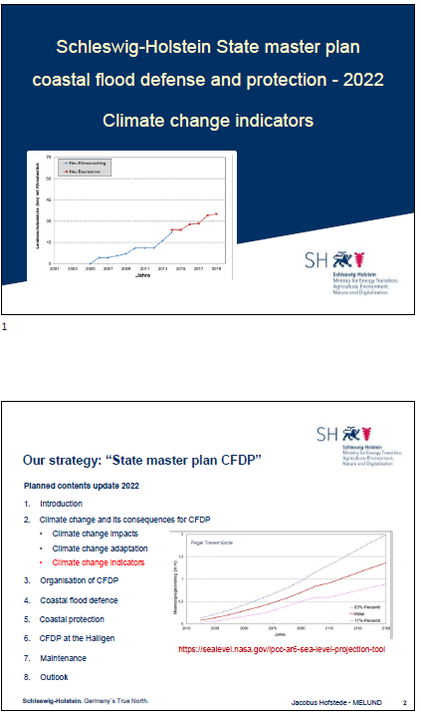
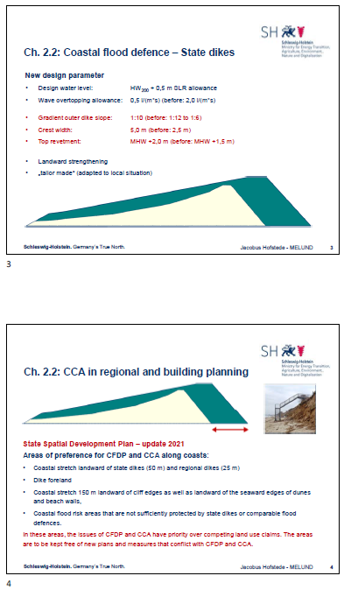
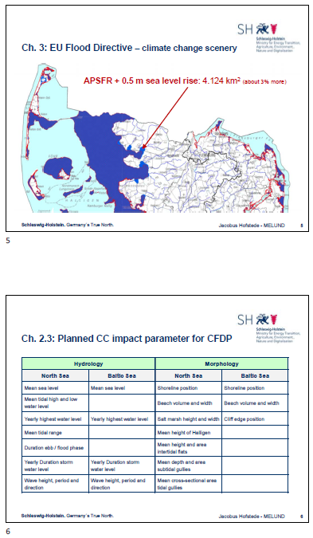
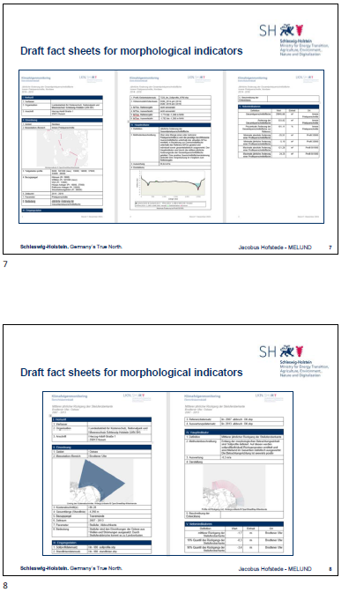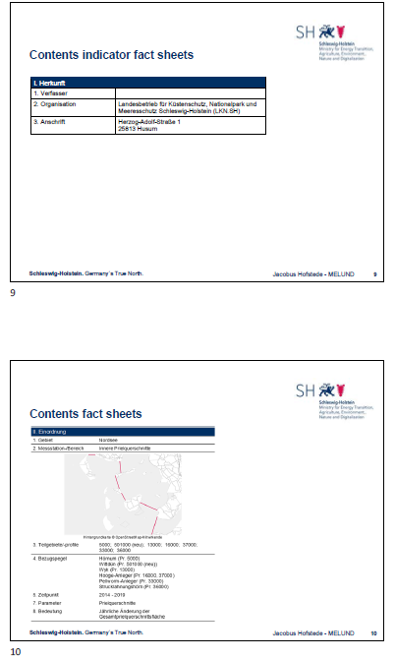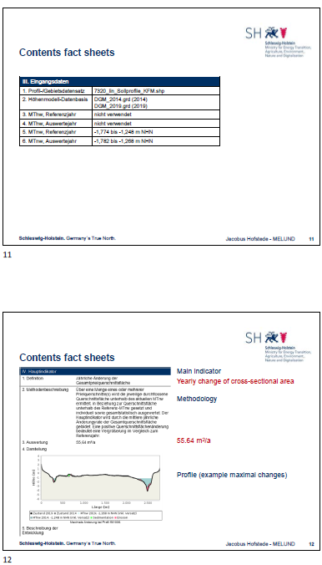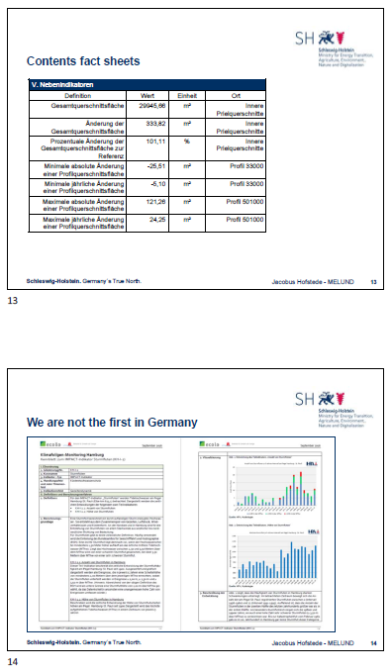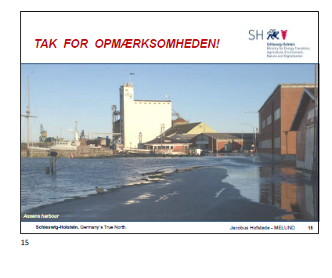

ANNEX 5: Recommendations for Ministerial Declaration: Climate change adaptation
The following list contains content (key words or full article text) for the preamble and “main part” of the Ministerial Conference Declaration as discussed by EG-C in their EG-C 11 meeting on 8 December. Discussion was on adaptation, but the text contains also few items on mitigation.
The group considered the UNESCO Draft Policy Document on Climate Action for World Heritage
PREAMBLE
- Climate change is a significant threat to the Wadden Sea World Heritage property, (potentially) impacting its Outstanding Universal Value, including its integrity and authenticity, and their potential for economic and social development at the local level (see UNESCO Draft Policy Document on Climate Action for World Heritage, amended)
- Underline article 24. of the Sylt Declaration 2010 to support the global and national efforts to mitigate causes of climate change at the regional level, by calling especially upon local and regional competent authorities and stakeholders, to work towards developing the Wadden Sea Region into a CO2-neutral area by 2030 or before, putting the focus on the special threats for coastal zones by global warming and sea level rise.
- Reaffirming that the overall goal of climate change adaptation in the Wadden Sea Area is to safeguard and promote the quality and integrity of the area as a natural and resilient ecosystem whilst ensuring the safety of its inhabitants and visitors;
- Realizing that climate change is globally accelerating, there is a need to act now
- We want to strengthen natural, cultural and social resilience
- That the CVI has identified the reduction of other pressures as a method to prevent and/or mitigate effects of climate change to the OUV;
- Nature based solutions can make a critical contribution to both climate change mitigation and adaptation; (from IUCN key messages) ..and power of World Heritage sites in protecting healthy intact ecosystems and essential regulation services for pepole and planet (IUCN, Peter Shadie)
- Links between natura and culture – holistic people-nature-culture approaches (IUCN, Peter Shadie)
- [Noting that by representing some of the world´s most outstanding natural ecosystems and by their important role in the mitigation of climate change with the large amount of carbon they store, the protection of natural World Heritage properties is considered the Convention's most impactful contribution to addressing climate change mitigation.] UNESCO Draft Policy Document on Climate Action for World Heritage page 28

SUSTAINABLE DEVELOPMENT
The ministers......
- Instruct the Wadden Sea Board to continue implementing the Trilateral Climate Change Adaptation Strategy, update the priorities contained therein where needed;
  - Instruct the Wadden Sea Board to contribute to climate change mitigation by safeguarding natural ecosystems that are carbon sinks and, when feasible and consistent with protecting the Outstanding Universal Value, undertaking actions to enhance carbon sequestration in natural systems. Such approaches would need to adhere to strict environmental and social safeguards and consider carbon storage permanence. [see UNESCO Draft Policy Document on Climate Action for World Heritage, page 28];
- Request the Wadden Sea Board to investigate how nature-based solutions for climate change adaptation can integrate coastal flood and erosion risk management with biodiversity goals, while considering a broader geographical and socio-economic context;
- Instruct the Wadden Sea B0ard to consider general principles for resilience, such as diversity, redundancy and connectivity (see Stockholm Resilience Center), and investigate adequate management options to be prepared to enhance the level of adequate management to safeguard the Outstanding Universal Value of the Wadden Sea (throughout all working groups as cross-cutting issue);
- Instruct the Wadden Sea Board to elaborate on potentially unavoidable ecosystem changes due to climate change and consider the consequences with regard to compliance with the Outstanding Universal Values of the Wadden Sea.
- Instruct the Wadden Sea B0ard to investigate which pressures on the Wadden Sea ecosystem should be reduced to improve resilience and thus safeguard the Outstanding Universal Value of the Wadden Sea while climate change is taking place.To further integrate dealing with impact of climate change in all fields of management of the Waddensea
- Report on the impact of climate change in all QSR thematic reports
- Strengthen trilateral research and monitoring on the impacts of climate change on the Wadden Sea ecosystem and consider launching a trilateral climate monitoring programme.

